SOME MAIN TEACHING METHODS OF THE SPORT
WRESTLING

The sport wrestling, being one of the single combat’s types, is unique in the following that during the fighting it is allowed to carry out technical actions against the opponent on the mat, from the front, from one side, from behind in various positions.
Standing position, par terre, lying position.
The technical actions of the wrestling are systematized by the following terminology: projection, take down, shift, turn(roll).
Each group of actions differs from one another by its dynamics and amplitude of performance.
For organizing effective training processes for the beginners in wrestling, the trainer with his pedagogical approach tries to provide the regular attendance of the sportsmen to the trainings with constant staff, creating a really good team.
The trainer-teacher has to reasonably plan the system of training, which should improve the level of knowledge in mastering in technical actions and ability to perform in single combat.
During the training, the trainer must preserve the bases of the didactics “from the simple to the complicated'' and “from the easy to the difficult”. It is necessary to take into account these didactic principles during other processes of the training methods as well.
After training each technical action it is reasonable to teach also corresponding technical elements.
During the training the trainer has to take into account the age particularities (physiological difference) physical qualities of the youths as well as the period of their attendance to the trainings.
Training the wrestlers, first of all the trainer teaches them the initial positions of the wrestling:
standing position, (picture 1), par terre position (picture 2).
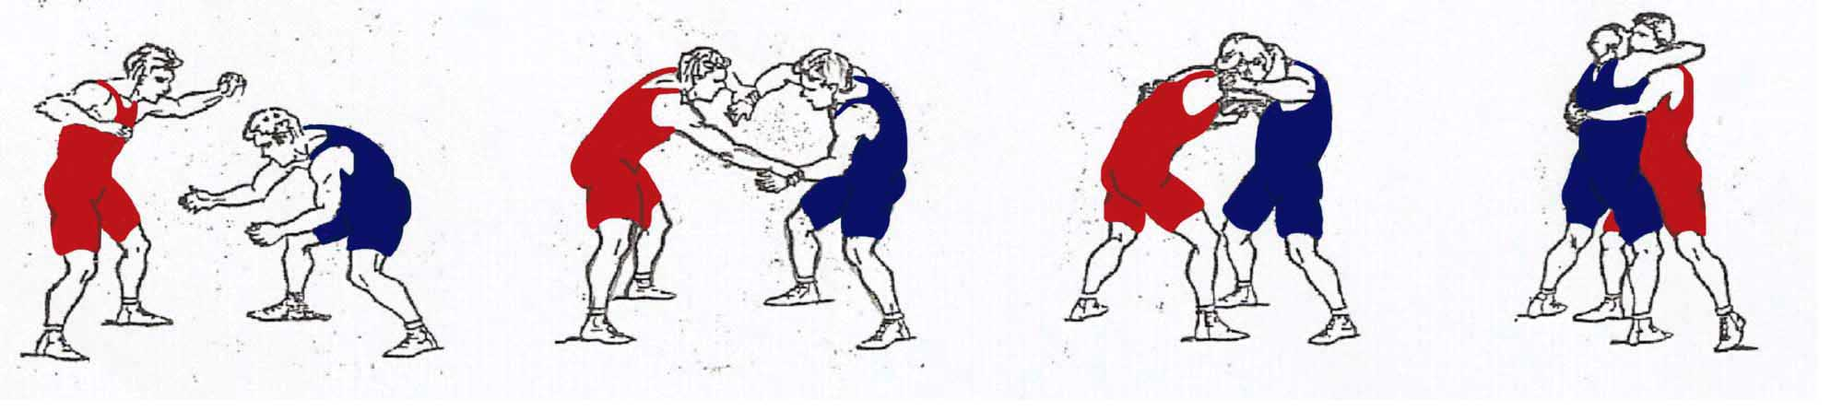
Picture 1
Standing position – distant position, average standing position, high standing position
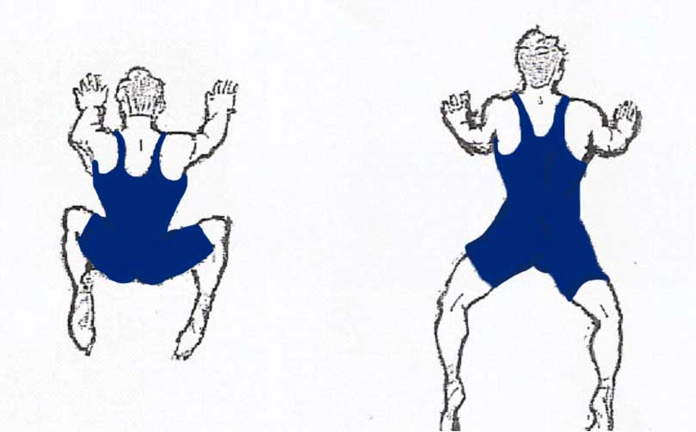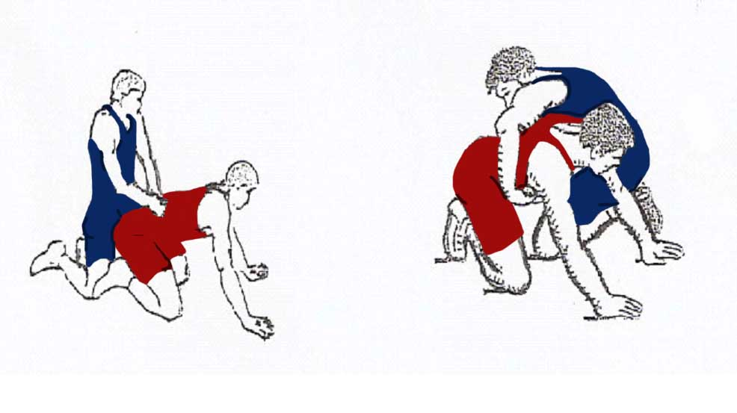
Picture 2
par terre position-average par terre, high par terre Starts to begin wrestling

Teaching the initial positions in wrestling, it is necessary to explain and show the stable equilibrium of the center-of-gravity.
The trainer teaches how to move on the mat: in forward, backward and sideways. At first they act alone, then with different partners, mutually seizures by wrists, shoulders and necks etc.
At first without resistance, then with resistance, trying to disturb one another’s equilibrium. (picture 3)
For this purpose, the trainer realizes the mobile games: “Cock - fighting” or “Riders combat” as well. (Picture 4)
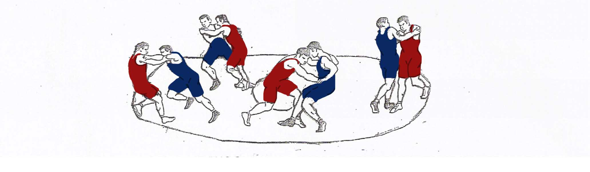
Picture 3
Exercises for strengthening the center-of-gravity
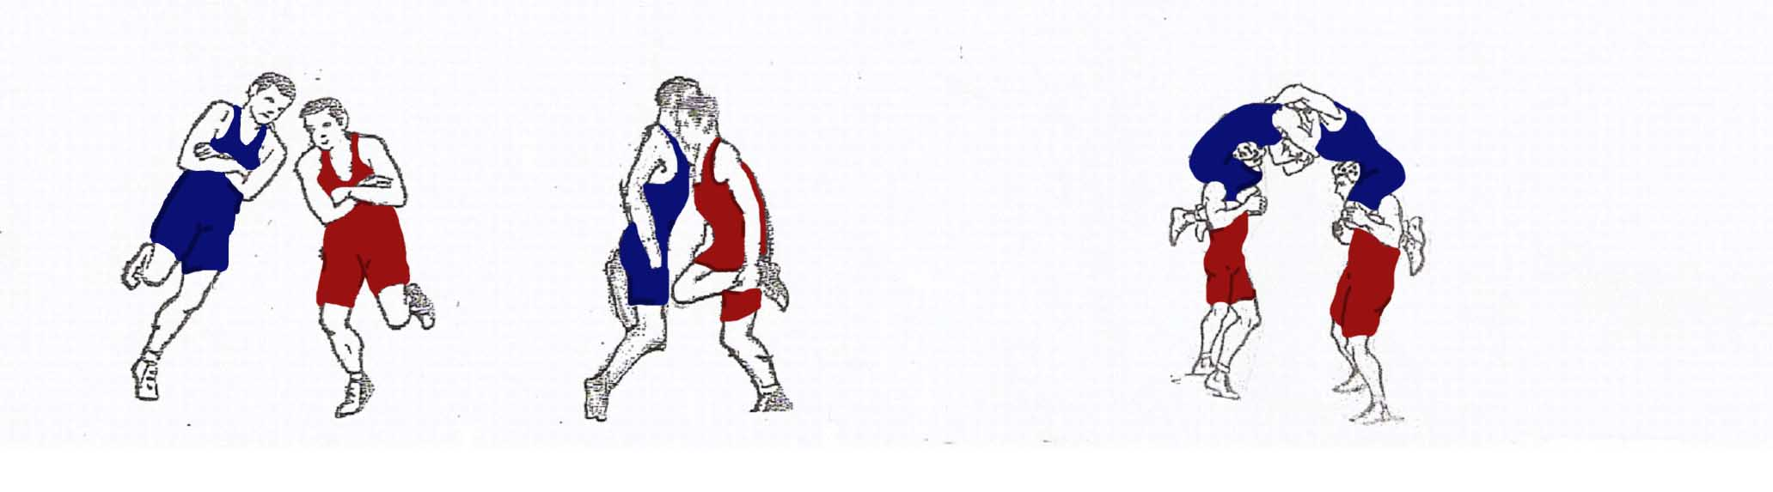
“Cock - fighting” Picture 4 “Riders combat”

During the training the coach shows and explains.
- The right controls in wrestling (Picture -5)
- The position “bridge”, explaining the meaning of the bridge, as a means of defense and as an element promoting the realization of a range of technical holds (picture-6). To select and study the actions which develop the special suppleness for strengthening the neck muscles, for acquiring the bridge firm position. (picture-7)
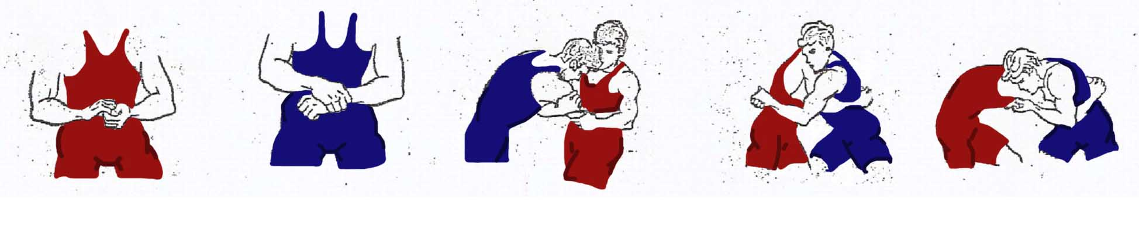
Picture-5
Different seizures in wrestling.

During teaching the bridge position, the trainer has to start with the bridge position on hands from the lying position on back and the standing position.
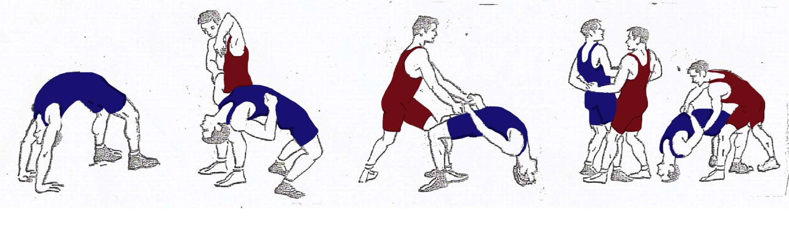
Picture-6
Bridge teaching exercises.
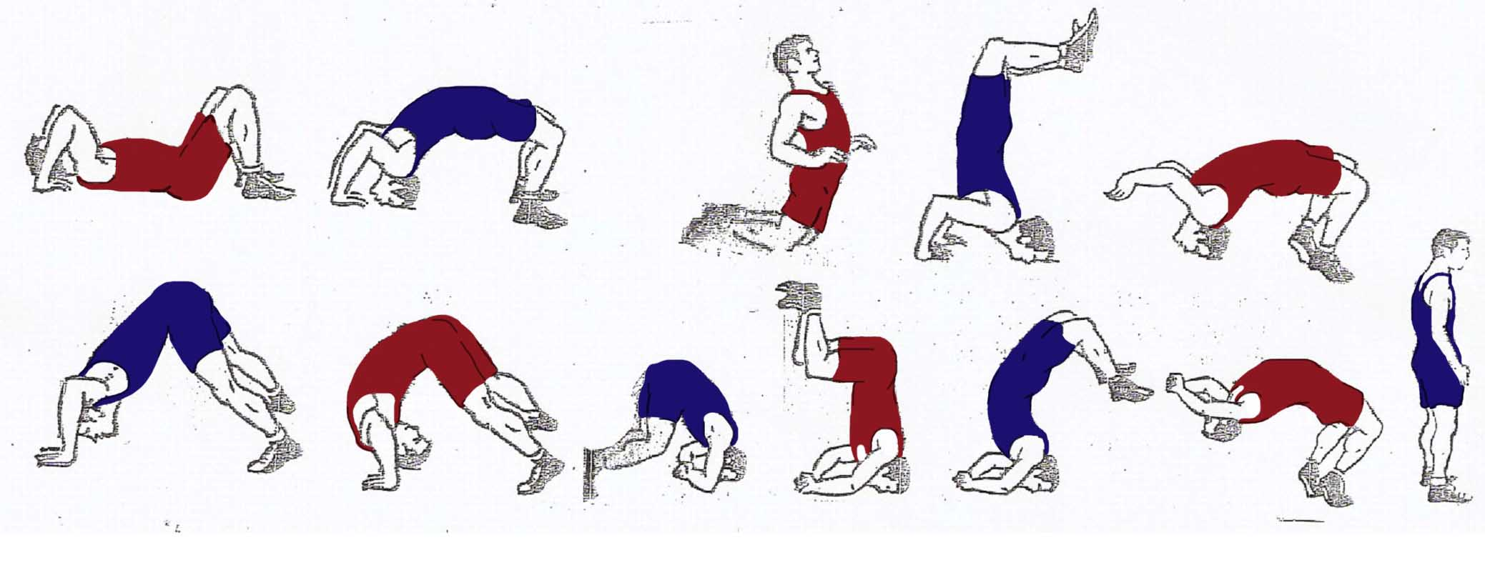
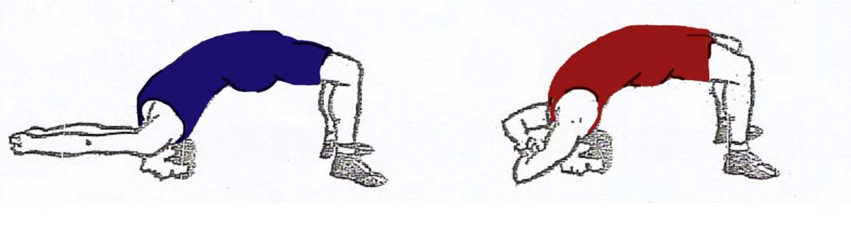
Picture 7
Bridge strengthening exercises.

Teaching the beginners the technical holds, it is necessary:
- To include a range of special acrobatic and gymnastic exercises in the preparatory part of the training to ensure the right collapse in performing the technical holds (picture-8).
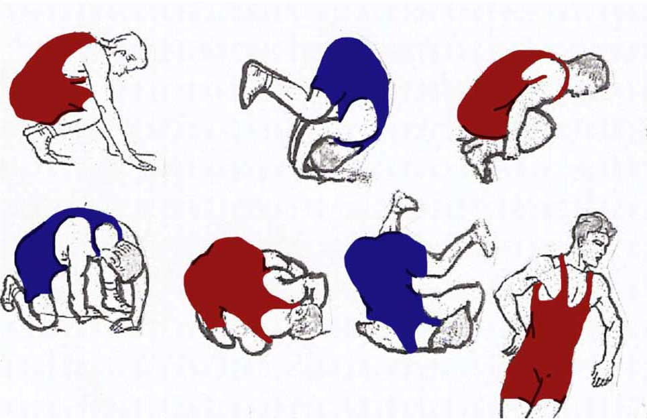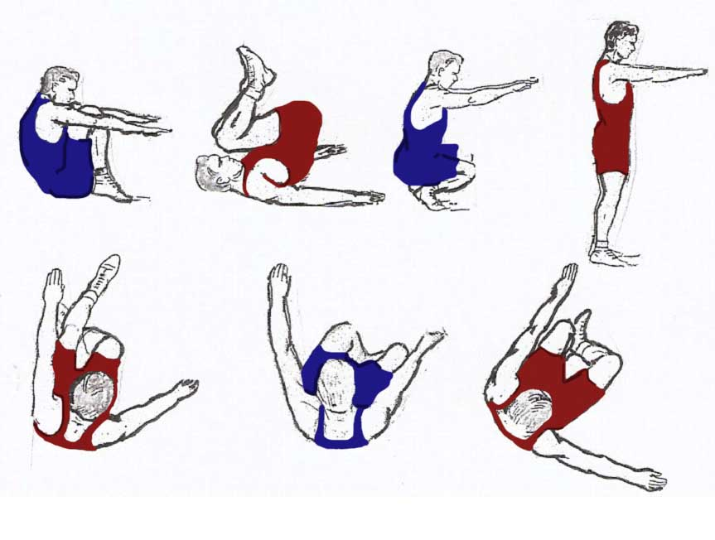

Picture 8
Acrobatic and gymnastic exercises

According to the training principle “from the simple to the complicated”, the following technical holds re suggested:

GRECO-ROMAN WRESTLING
THE STANDING POSITION:
- Back body lock, take down (picture 9).
- Head and arm, take down (picture 10).
- Arm drag, take down, (picture 11).
- Body lock, take down (picture 12).
- Inside arm (picture 13).
- Body lock, suplex (picture 14).
- Body lock, shift forward (picture 15).
- Arm and body, hip toss (picture 16).
- Arm and body, shift sideways (picture 17).
- Head and arm, hip toss (picture 18).
-Inside arm hip toss (picture 19).
- Arm and body lock, suplex (picture 20).
- Arm and body lock, suplex with shift (picture 21).
- Over and under, suplex (picture 22).
- Arm and body, suplex sideways (picture 23).
- Body lock, shift with lifting (picture 24).
- Double over hook suplex (picture 25).
- Head and arm lock, suplex (picture 26).
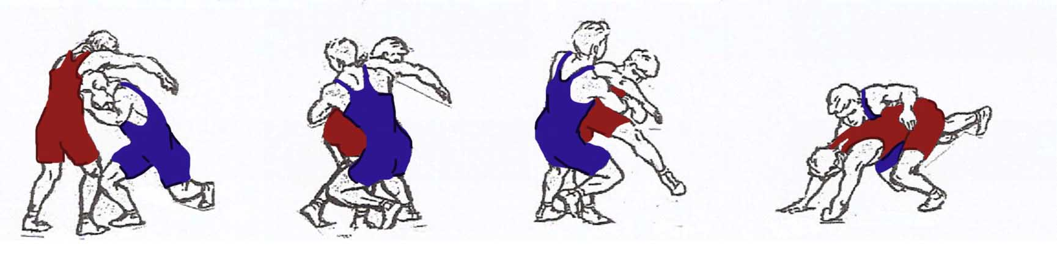
Picture 9
Back body lock,take down.
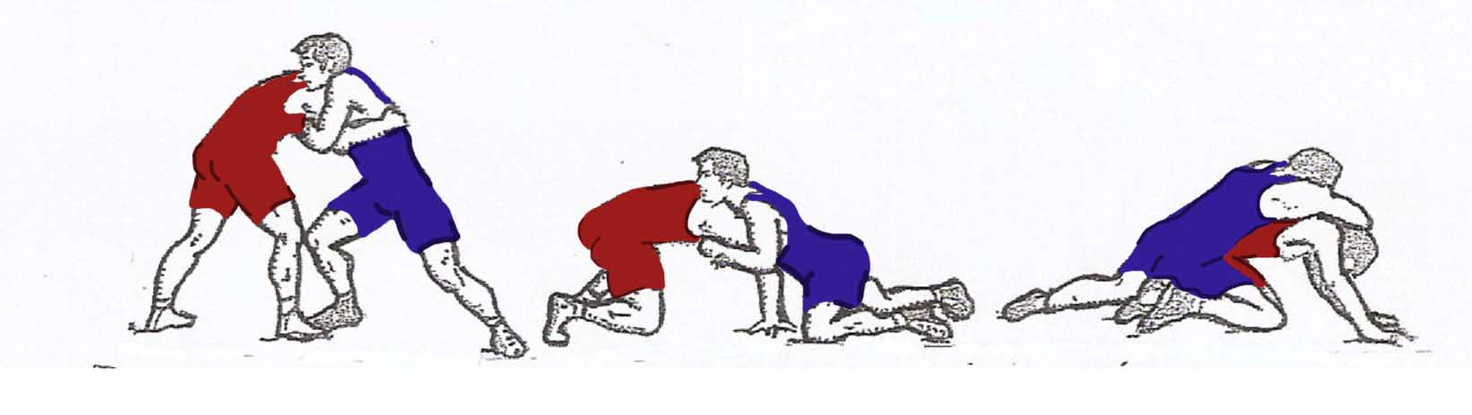
Picture 10
Head and arm take down.

During teaching the trainer realizes both speaking and showing methods. Taking into account the difficulty of the studied element or hold, the trainer has to put into practice an integral or step by step teaching method.
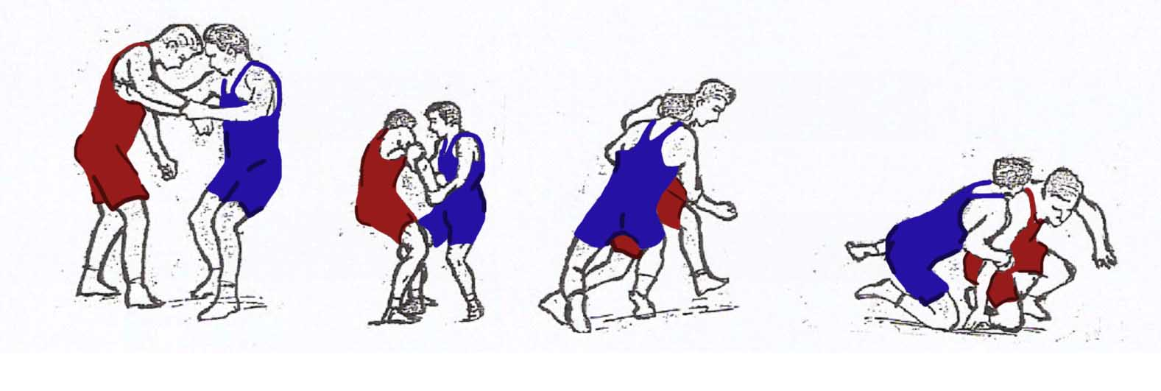
Picture 11
Arm drag, take down.
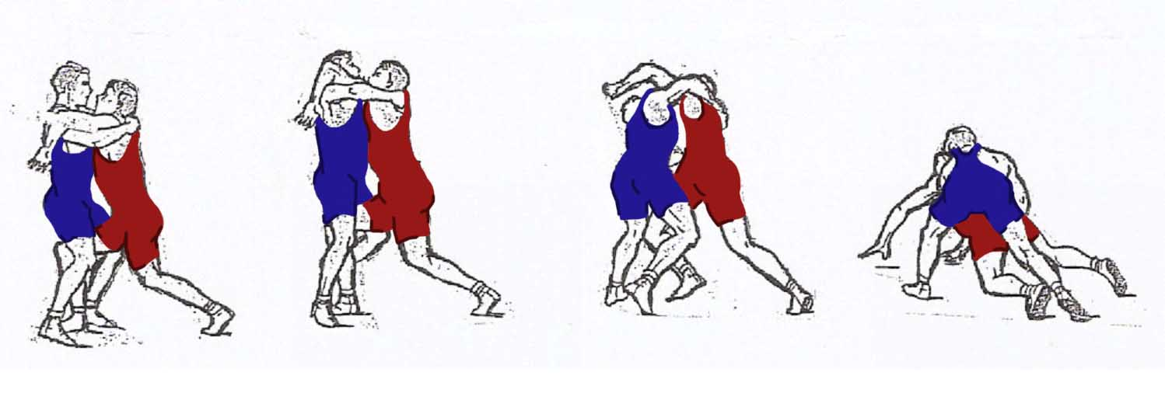
Picture 12
Body lock, take down.
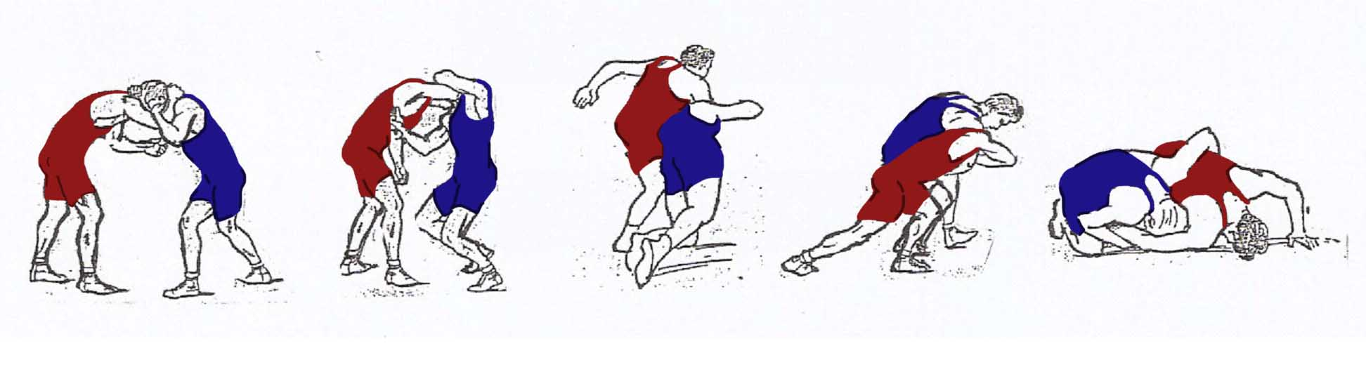
Picture 13
Inside arm, take down.
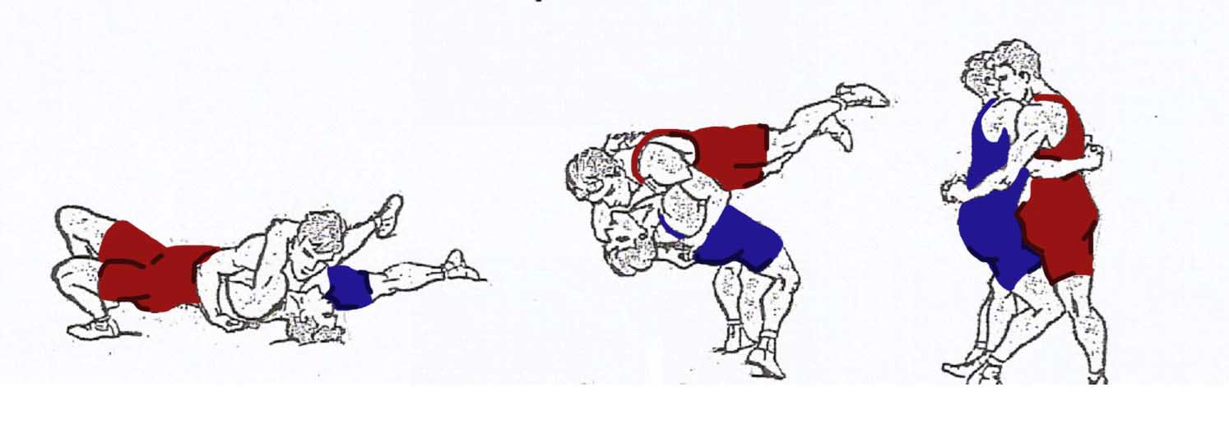
Picture 14
Body lock, suplex.
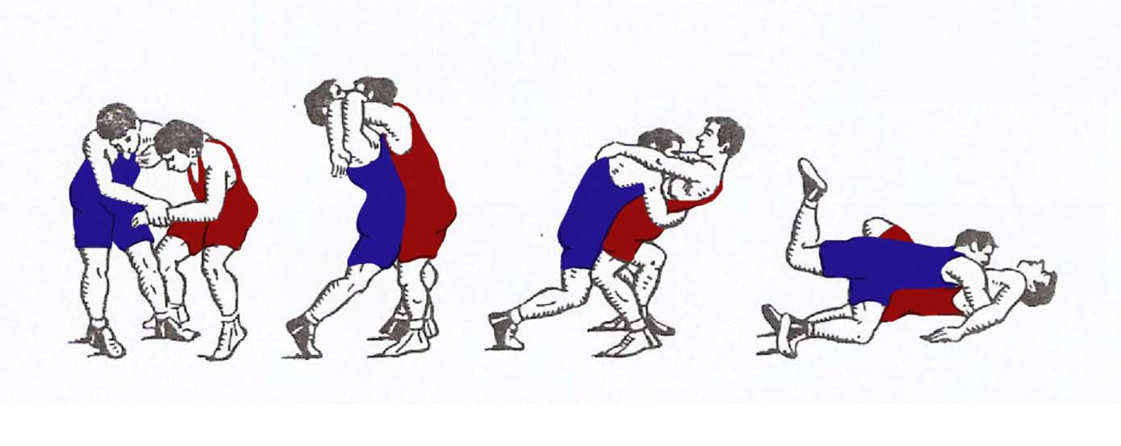
Picture 15
Body lock, shift forward.
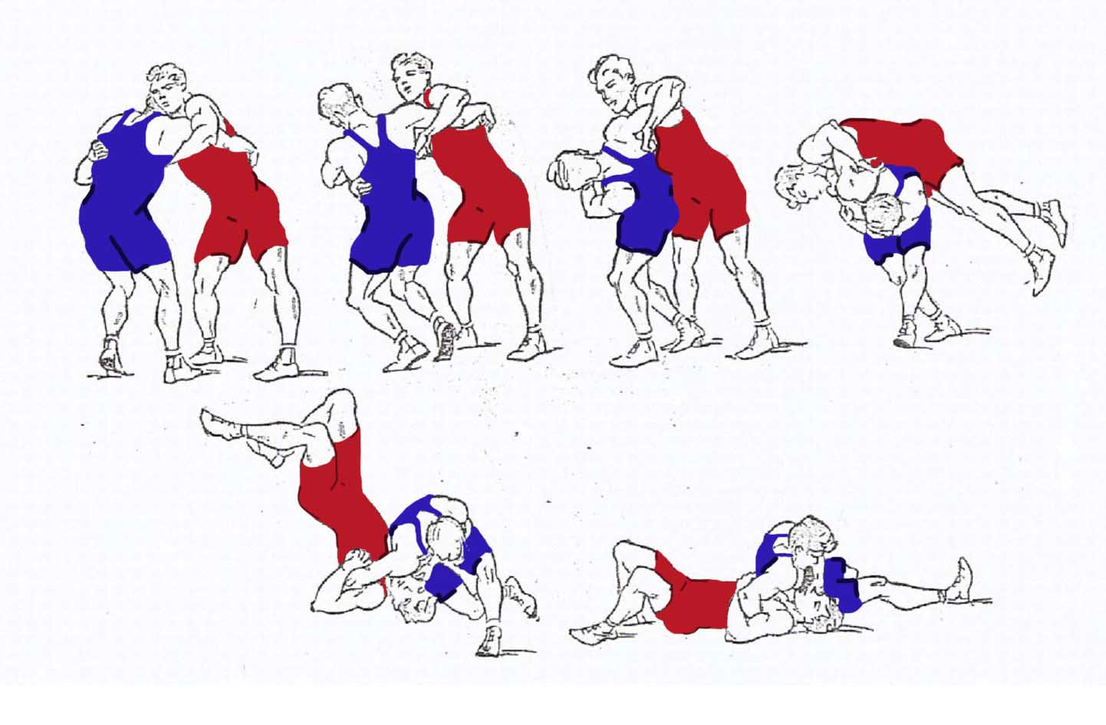
Picture 16
Arm and body, hip toss.
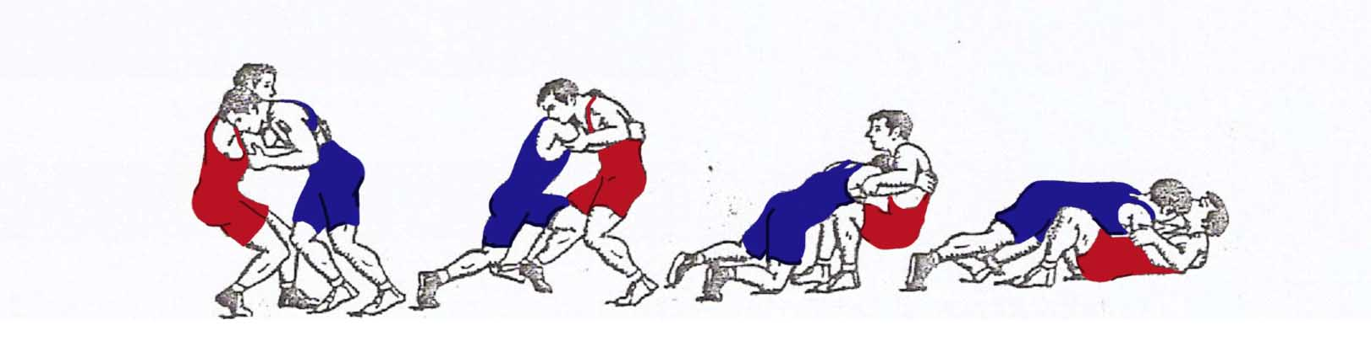
Picture 17
Arm and body, shift sideways.
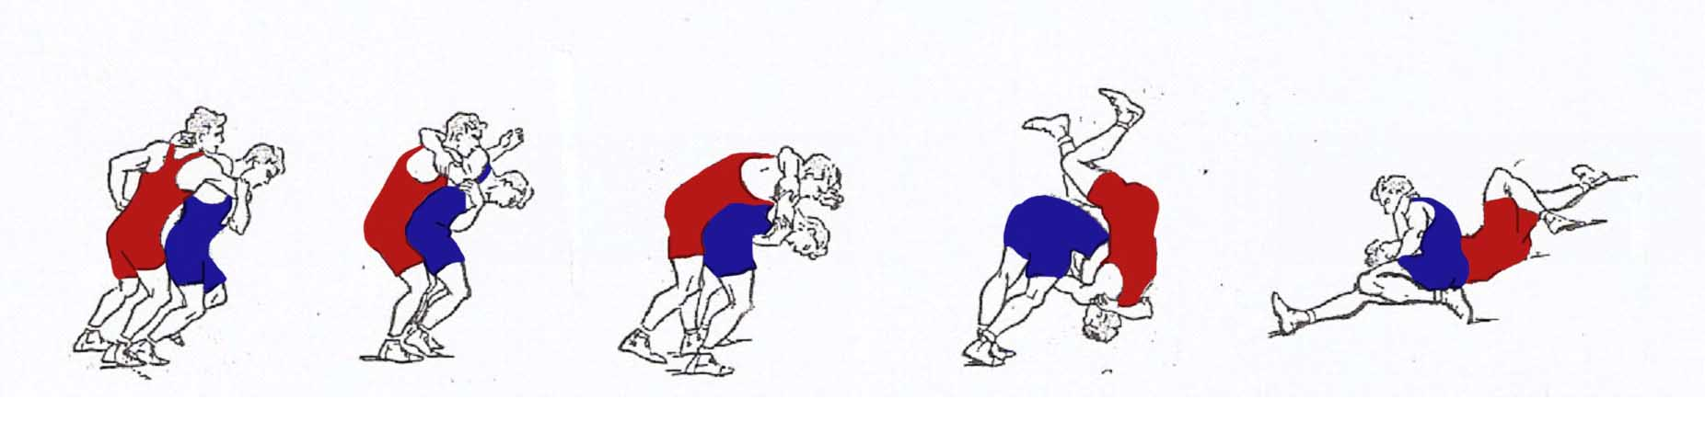

Picture 18
Head and arm, hip toss.
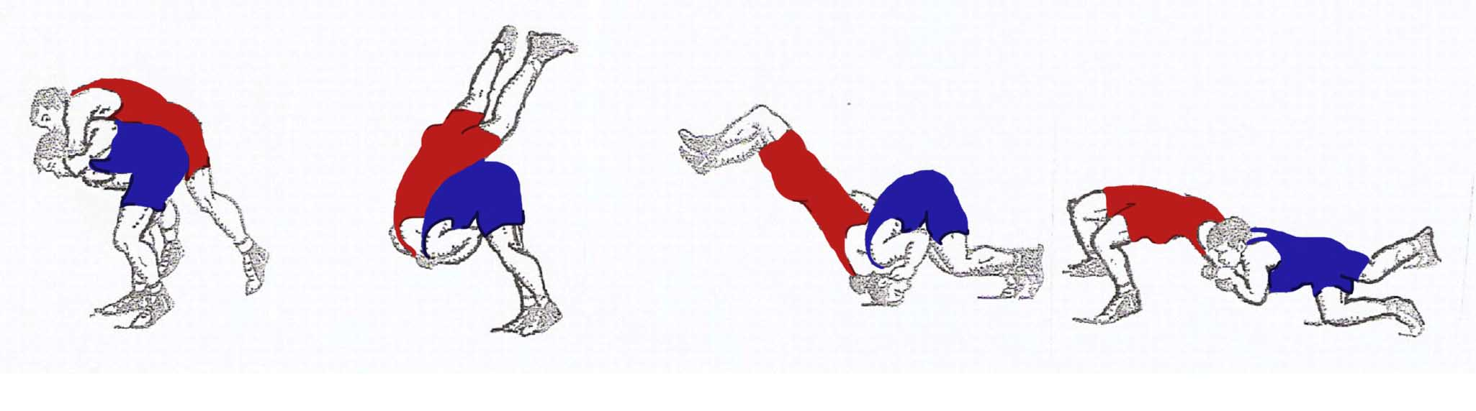Picture 19
Inside arm, hip toss.
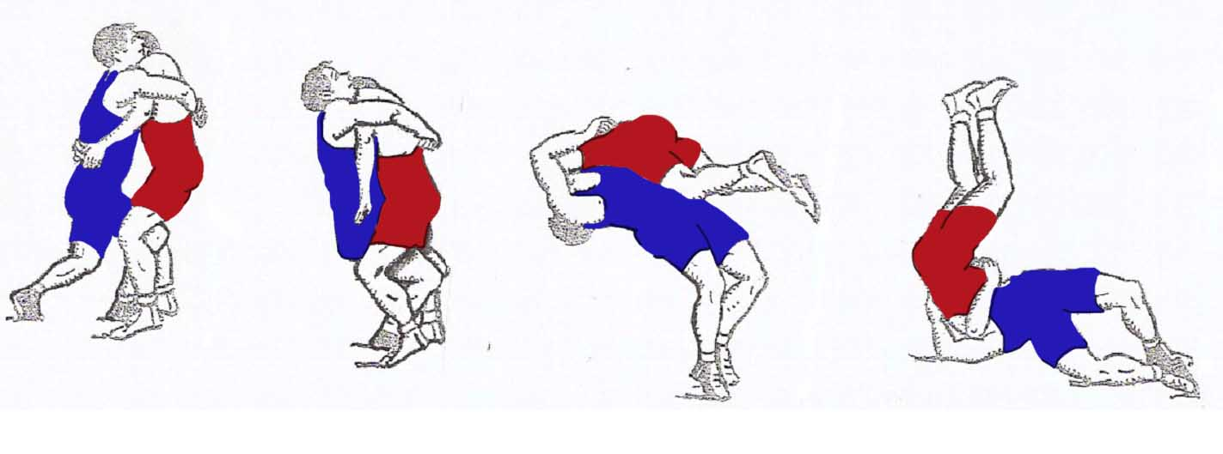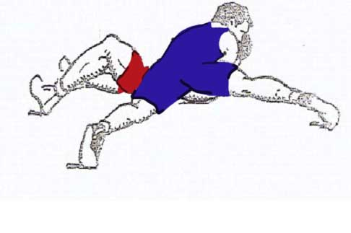
Picture 20
Arm and body lock, suplex.
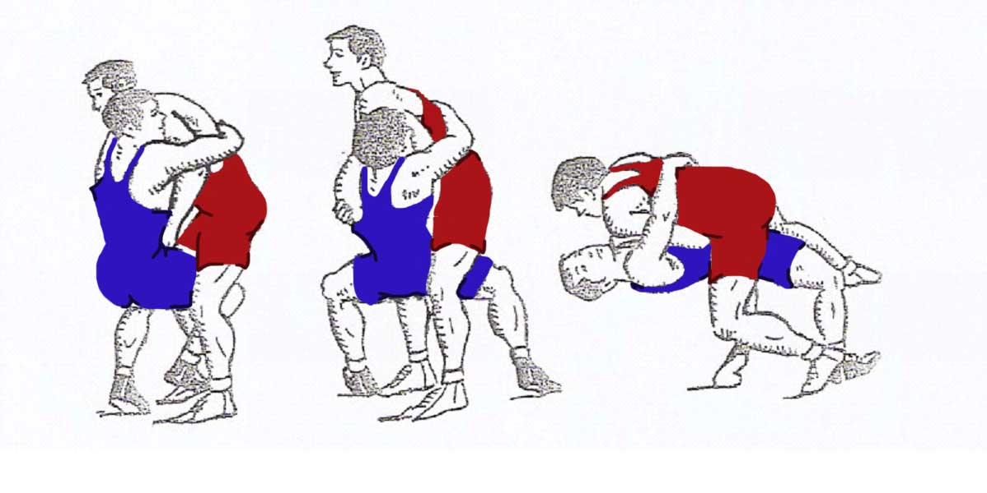
Picture 21
Arm and body lock, suplex with shift
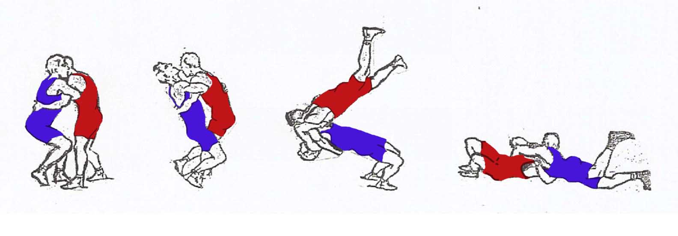
Picture 22
Over and under, suplex.
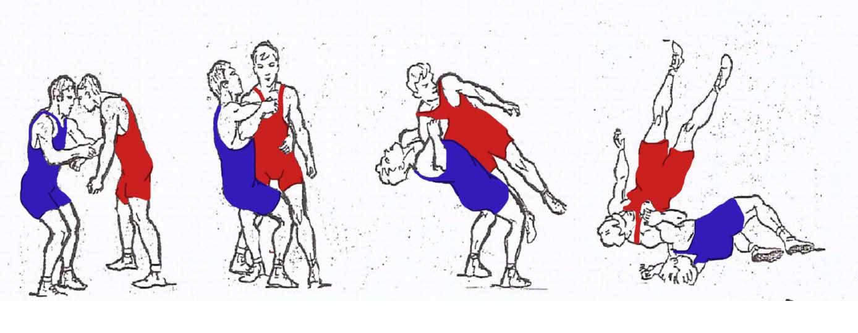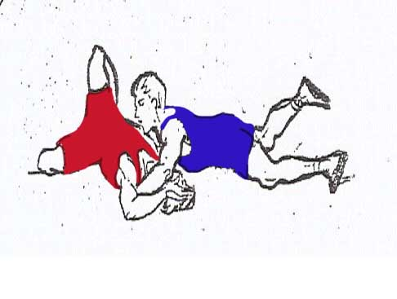
Picture 23
Arm and body, suplex sideways.
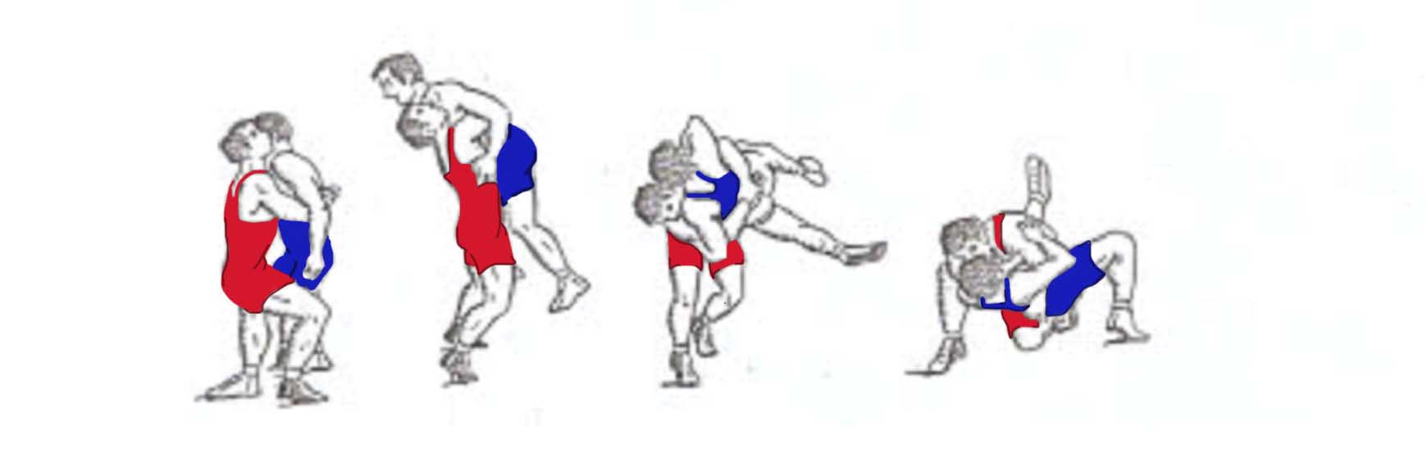
Picture 24
Body lock, shift with lifting
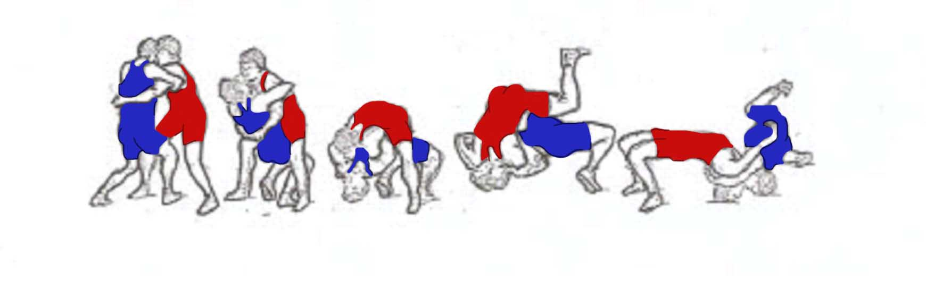
Picture 25
Double over hook suplex
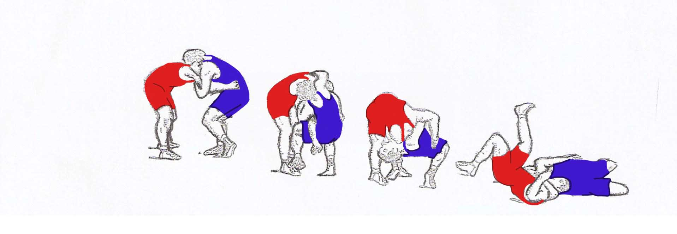
Picture 26
Head and arm lock, suplex.
THE PAR TERRE POSITION:
- Double arm lock, forward poll (picture 27/1).
- Head lock bridging (picture 28/2).
- Head lock, turn (picture 29/3).
- Head lock inverse, turn (picture 30/4).
- Reverse body lock, turn (picture31/5).
- Arm lock, turn backwards (picture 32/6).
- Under hook lock (picture 33/7).
- Arm lock, turn (picture 34/8).
- Head and arm back lock (picture 35/9).
- Arm back lock (picture 36/10).
- Body lock, bridging (picture37/11).
- Reverse body lock (picture38/12).
- Body lock lift suplex (picture 39/13).
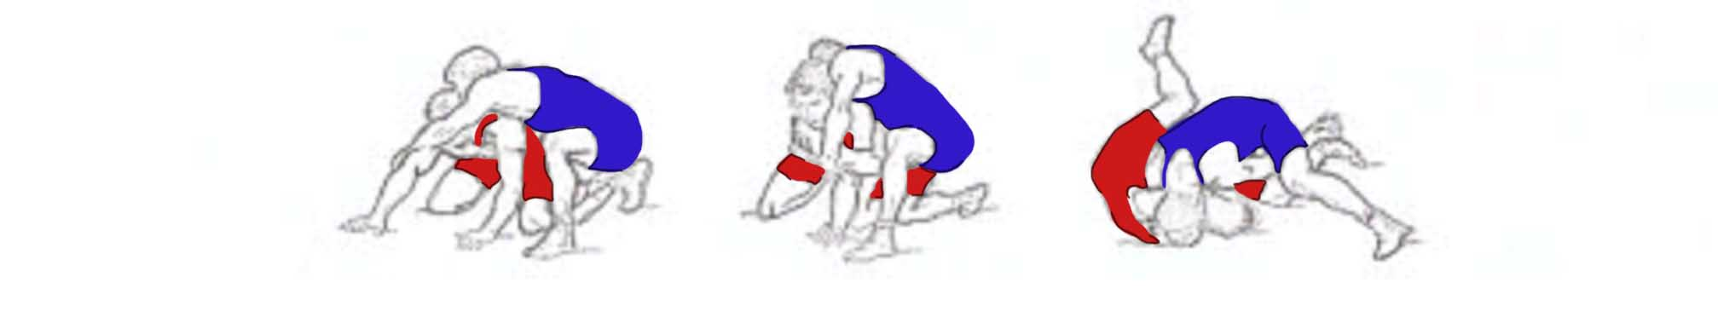
Picture 27/1
Double arm lock, forward poll
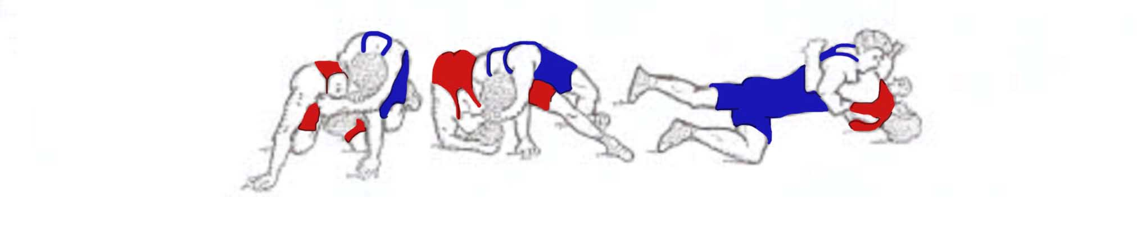
Picture 28/2
Head lock bridging

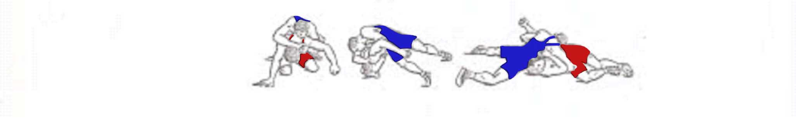
Picture 29/3
Head lock, turn
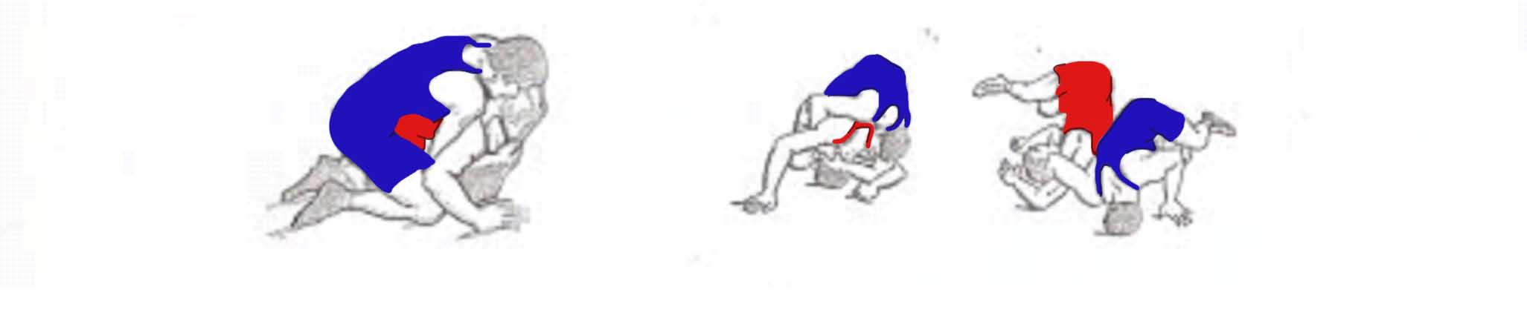
Picture 30/4
Head lock inverse, turn
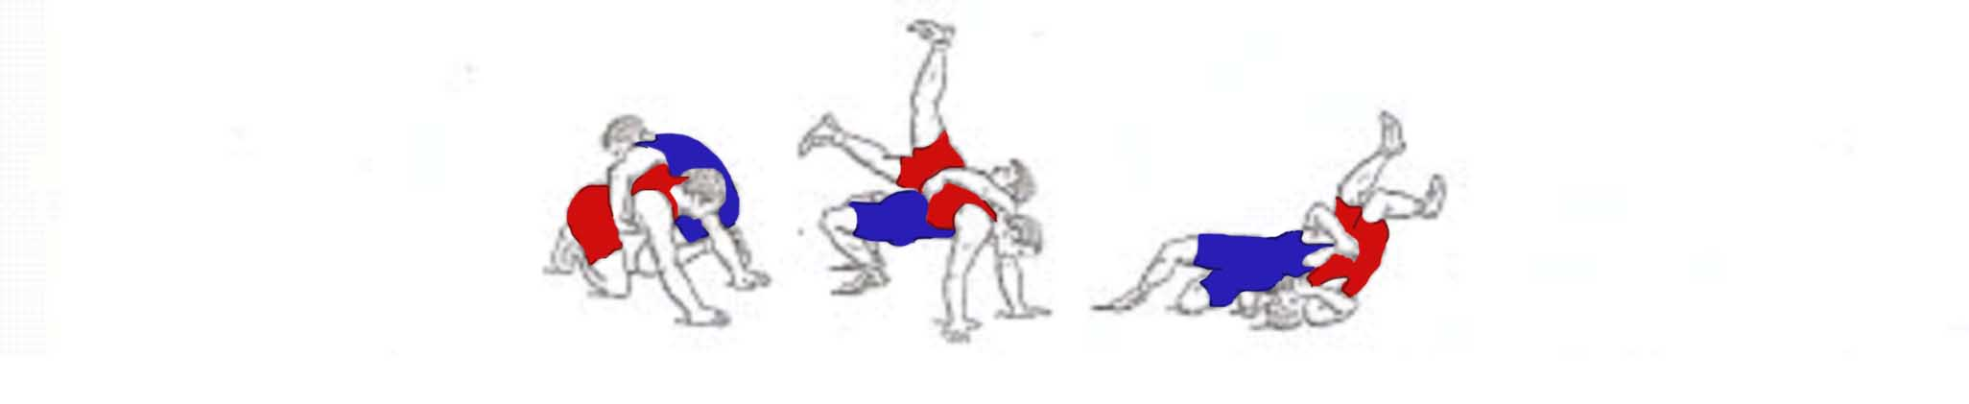
Picture 31/5
Reverse body lock, turn

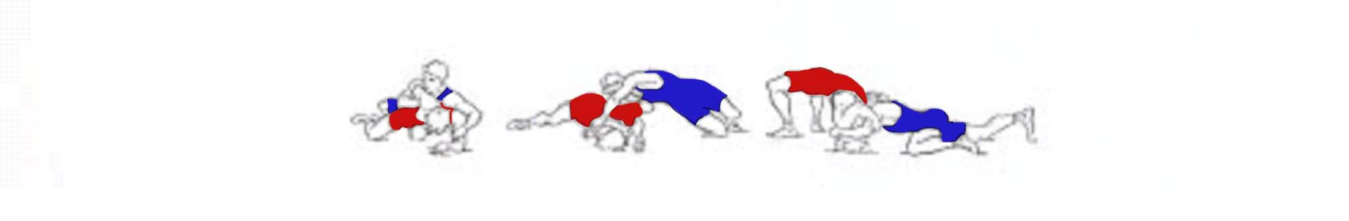
Picture 32/6
Arm lock, turn backwards
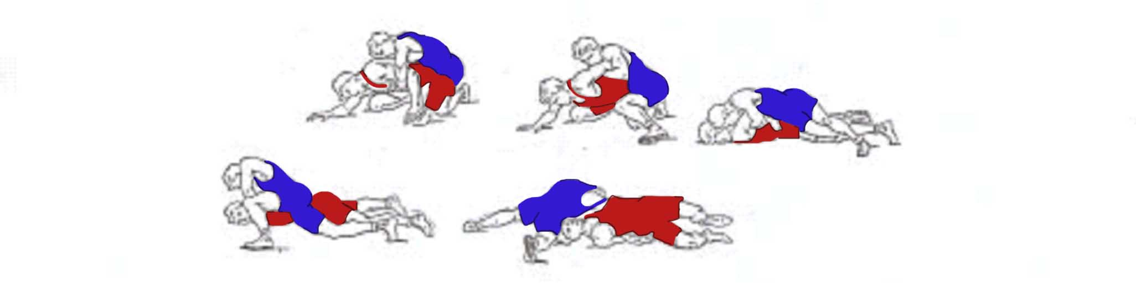
Picture 33/7
Under hook lock
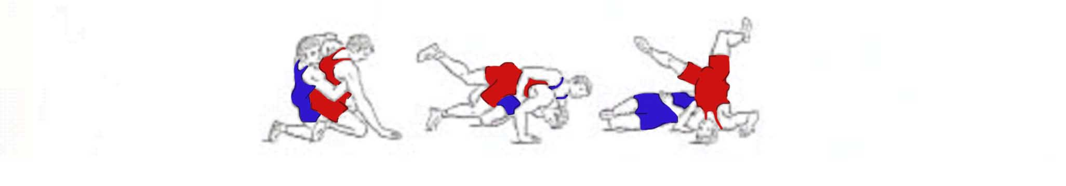
Picture 34/8
Arm lock, turn

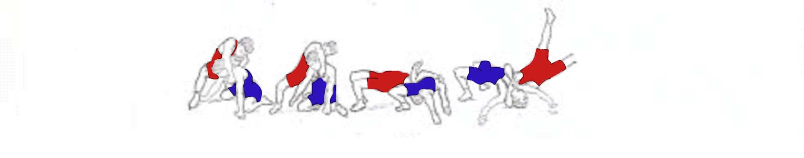
Picture 35/9
Head and arm back lock
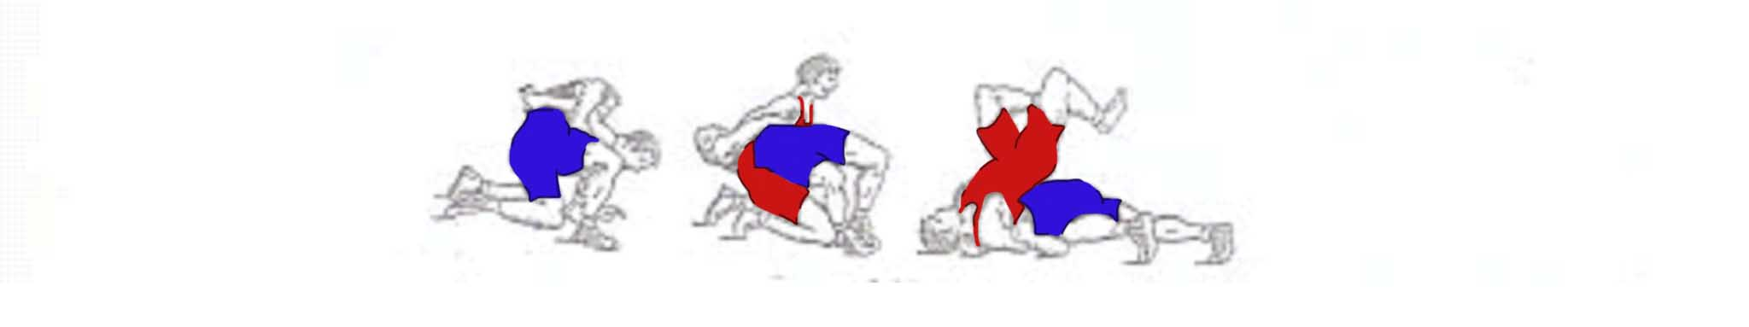
Picture 36/10
Arm back lock
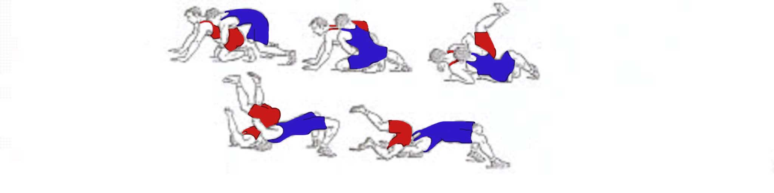
Picture 37/11
Body lock, bridging
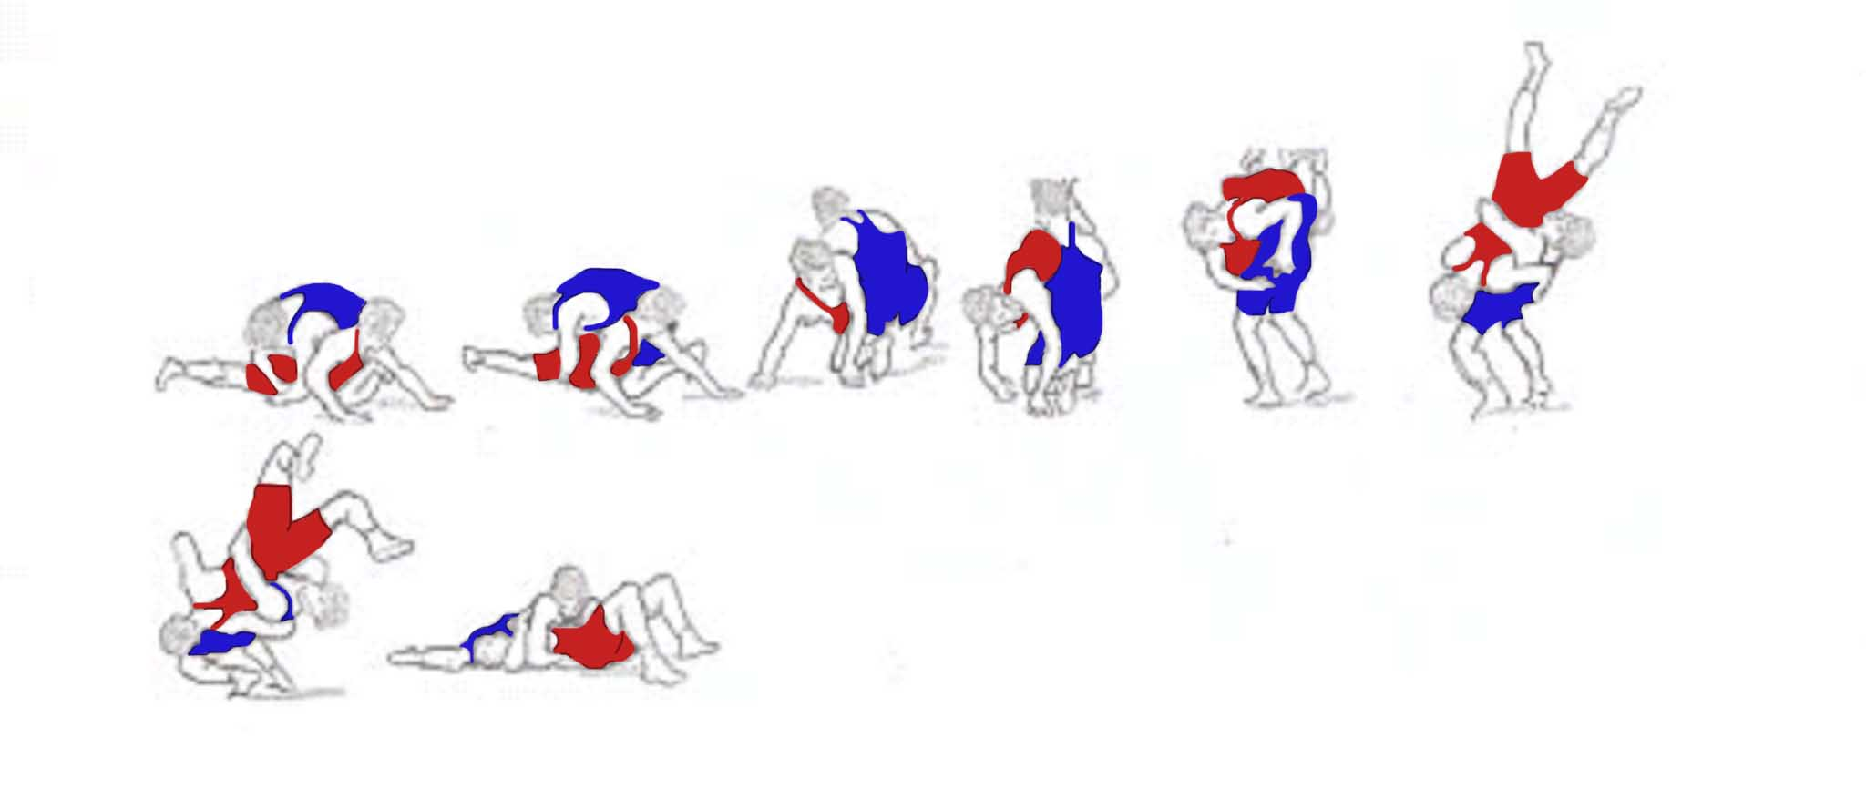
Picture 38/12
Reverse body lock
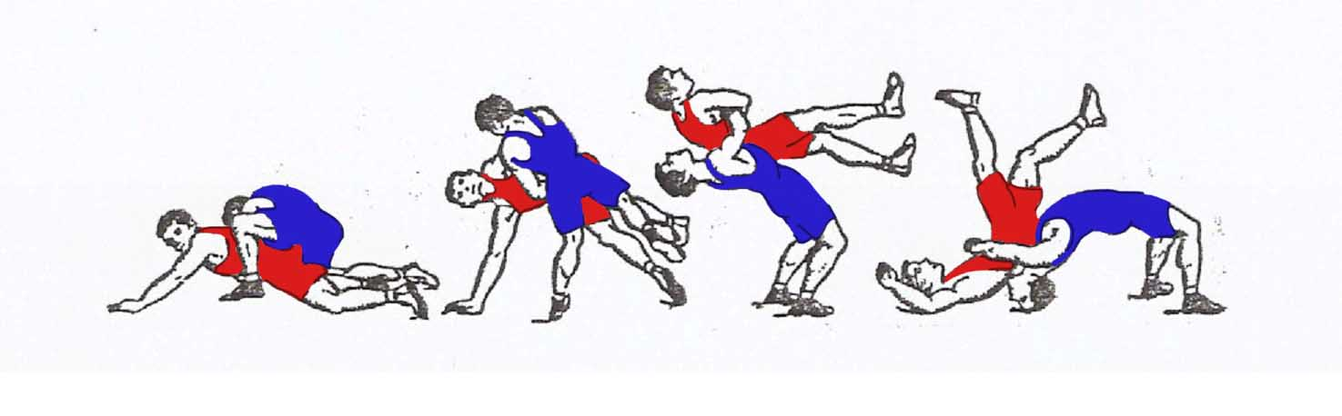
Picture 39/13
Body lock lift, suplex.

During teaching the trainer realizes both speaking and showing methods. Taking into account the difficulty of the studied element or hold, the trainer has to put into practice an integral or step by step teaching method.
However, it is necessary to teach the simple technical actions mainly by means of the integral method. The combinative holds of the wrestling techniques should be taught step by step for the group of cadets and youths.
During the teaching, the trainer has to give a name and characterize the holds and then to show them. While explaining it is necessary to show:
- the initial position for performing an hold.
- Seizure (control).
- Performance (execution).
- The partner (opponent) effective keeping after execution the hold.

However, taking into account the character of the technical hold, while teaching, it is necessary to explain the importance of action performing elements, in which phase the trainees need to make more efforts for facilitating the performance.
For instance, during the performance 1/ throw “Hip toss”, if not mention that after
turning on back the attacker, inclining forward and straightening knees, has to pull jerkily the partners (opponents) gripped hand and neck towards himself, otherwise the throw will be performed ineffectively. If the developing hold is performed slowly, in future it will not be completely realized against the competitor.
2/While teaching the “Double arm lock” in par terre, it is necessary to explain, that pulling the gripped hands towards himself, the attacker jerkily breasting has to push the opponent’s sideways.
If that very action is performed only by means of pulling the opponent’s hands towards himself, this performing action will become more complicated. While teaching the wrestling techniques, it is necessary to pay attention to the rapidity of performing very fast. The technical actions' performing speed has a great significance in the combats. However in the teaching process (only), the coach shouldn’t require the wrestlers to perform the action with high speed, so that they can digest the movement techniques correctly.
Besides repeating the technical action with the partner, the trainer teaches some special exercises imitating the given action. . These imitating exercises can be performed during the preliminary parts of training. The imitating exercises are performed separately or with the partner (picture 40/14).
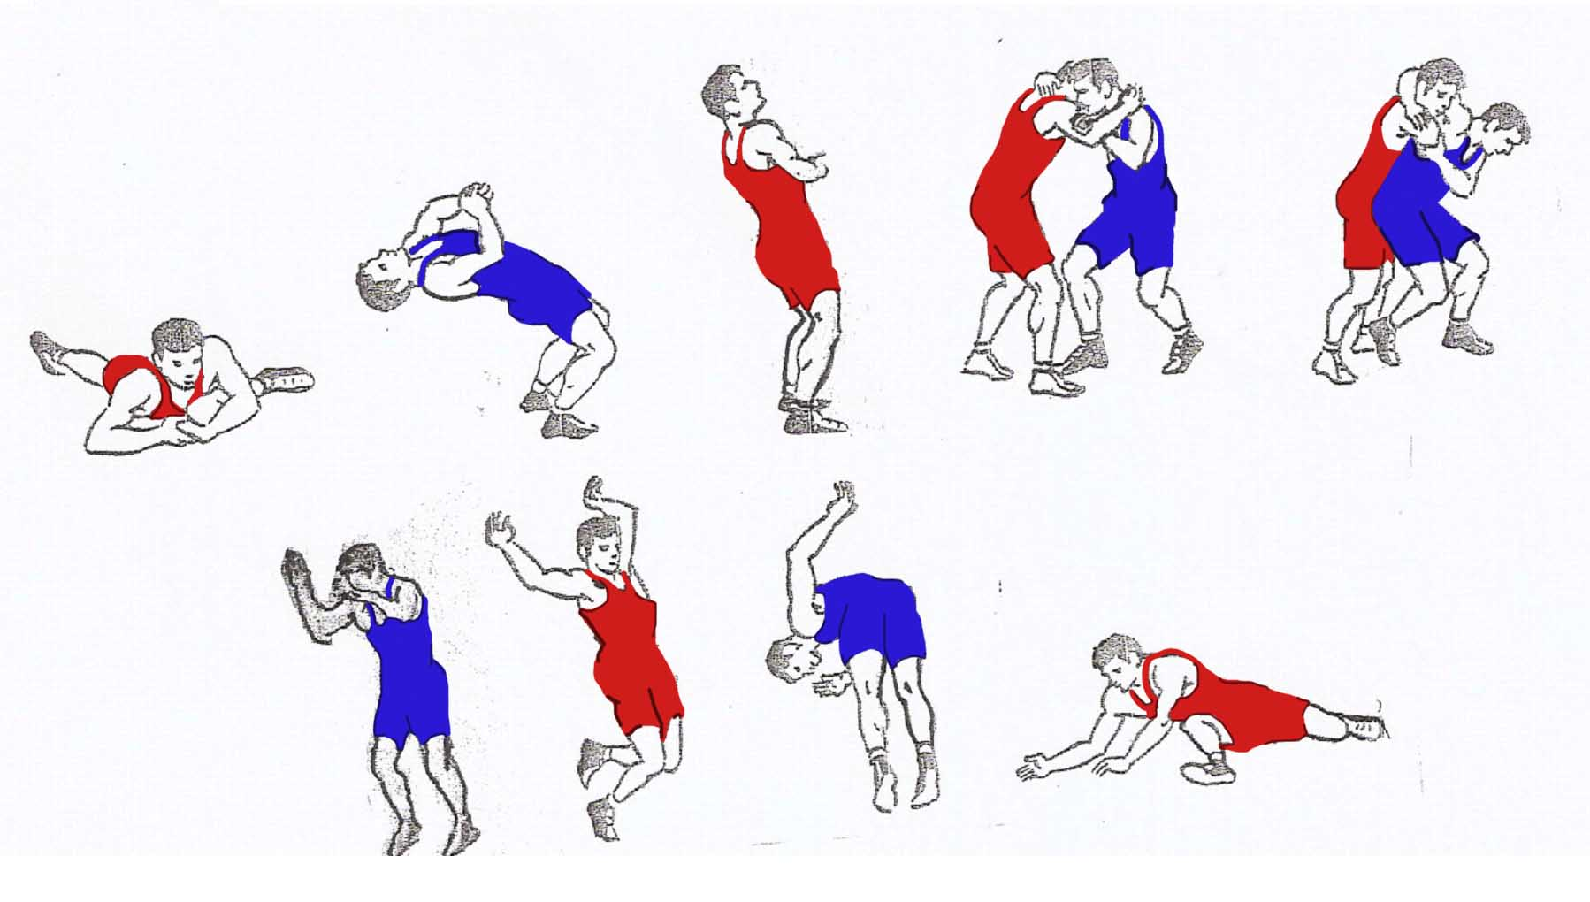
Picture 40/14
Some exorcises imitations technique.

For learning and improving the throw from the standing position and while the body lock turn, from par terre position, it is offered to realize a wrestling mannequin (dummy). It is desirable to provide with 3-4 different sized wrestling mannequins each group consisting from 12 to 15 wrestlers. A special speed is effectively developed with a wrestling mannequin (dummy).
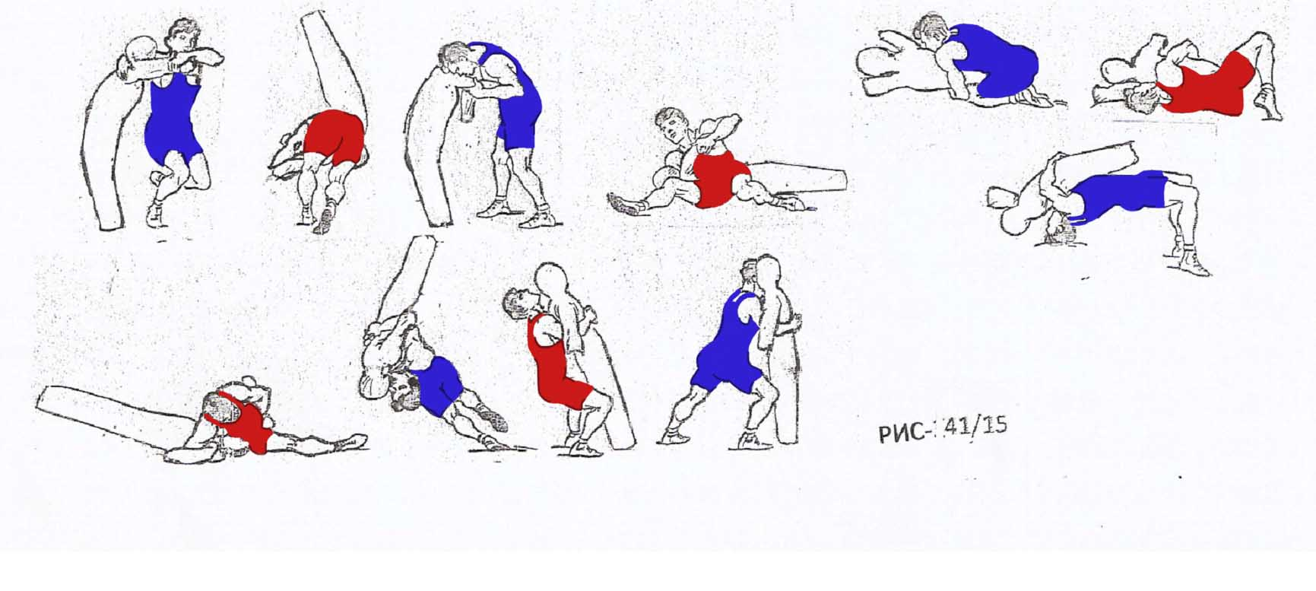
Picture 40/15
Exercises techniques the holds with dummy.

It is possible to start learning the defense techniques of simple holds after passing one training. The interval between learning the hold techniques and defense depends on the difficulty of the technical action's performance. The trainer can start teaching the defense of throws” hip toss”,” suplex”, not sooner than in 1-2 weeks after teaching the action. While teaching the contraction of wrestling techniques, the coach should take into account that the “overturn” of the contr- actions and “take down” to par terre are easier, than teaching the throwing holds in the standing position and par terre.
The contractions are taught after digesting the hold and its defense. That's why the coach can start teaching simple actions (“take down” the standing position), not sooner, than 1-2 weeks after teaching the technical action's defense.
The contractions throws “suplex” and “hip toss” can be taught not sooner than in 2 weeks after teaching the defense of action techniques.
The coach should take into account, that there are several varieties of thows “suplex”, through the back “hip toss”, “take down” to par terre etc.
For instance: 1) “head and arm lock, hip toss”, has the following contractions:
- Body lock, suplex.
- Back body lock, take down.
- Arm and body lock, shift
2) “Arm drag, take down”, has following contraction:
- Inside arm lock, hip toss.
- Arm lock, shift.
- Arm lock, take down.
- Wrist and body lock, throw back.
While teaching the contraction, the coach has to preserve all the didactic bases, “from the simple to the complicated” as well as the integral and step by step teaching methods.
Moreover the coach has to take into account the general methods’ particularities for training the wrestlers, it is better not to teach the “arm and body lock, suplex”
and other technical holds and contractions complex, sooner than the second year of training and so that the wrestler is not less than 13 years old.
The final phase of the teaching method for wrestling techniques is a kind of training of the combinative holds.
The combinative action's performance is one of the attacking types, during which the attacker carries out 2 technical actions, the first action is false. The competitor, while defending, creates convenient conditions against the first action for realizing the second one.
There is a law concerning to the training methods of a sport wrestling and a range of other types of the single sport: every defense from one technical action, is a convenient condition for performing another action. The professional coaches realize the above mentioned law in a tactical training for the leading wrestlers.
At the initial preparation period of training the coach teaches more various technical actions, and then it becomes much easier to teach the combinative actions. If the wrestler masters two or three combinative actions, he will have a great opportunity to gain an advantage in the competitions.
The wrestlers should be physically trained for digesting the combinative action completely. Besides the technical training, the level of the physical training has to correspond to the dynamics' requirement for the modern wrestling.
For example, the performance of the combinative action. If the second phase of the combinative action is not performed with a high speed at the right time, action will be performed ineffectively. Thus the attempt to attack will not be accomplished successfully, because of the lack of the necessary speed.
Another example: the attempt to perform the hold at the end of the third period of the match, because of the tiredness, the attacker does not accomplish the started combinative action as a result the match is lost.
The teaching method is one of the parameters in the complex work for wrestlers training. However the complex of the coach’s creative work, besides the total teaching of the technical elements of wrestling, includes the following:
- perfecting the techniques and tactics
- developing the speed-strengthening qualities (physical strength, speed, endurance and other physical qualities).
- Improving the reaction of the vestibular apparatus during the match.
- Improving the psychological stability.
- Upbringing the sport regime character and adapting to the diet for keeping the weight.
If there is a lack of above mentioned parameters, the process of training the young individual, for converting into a champion in future can be broken.

Prof. S. Kazarian

